From Data to Insight: A Comprehensive Data Science Exploration Report

Introduction

Based on the provided dataset, here is an overall general introduction:  
  
The dataset contains 29 observations of patients' HbA1c, risk, and patient information. The patients are categorized into two groups: adolescent and adult. The HbA1c levels range from 4.46% to 16.2%, indicating a significant variation in blood sugar control across the patients. The risk level ranges from 0.4466 to 1.6722, indicating a moderate to high risk of developing diabetes-related complications. The patient information includes age, gender, and BMI, which may also impact blood sugar control and overall health.  
  
Some key observations from the dataset include:  
  
1. HbA1c levels are highest among adolescents (mean = 6.2%, n = 5), suggesting that this age group may require more frequent monitoring and interventions to manage blood sugar levels.  
2. The risk level is higher among adolescents (mean = 1.102784, n = 16) than among adults (mean = 0.446600, n = 25), indicating a greater likelihood of developing diabetes-related complications in this age group.  
3. There is a significant positive correlation between HbA1c levels and risk

Summary Statistics

Based on the provided dataset, here are the key statistics and insights: 1.  
Count: The dataset  
contains 31680 observations.  
2.  
Mean: The mean value of BG, CGM, CHO, and insulin is 113.15, 116.4,  
0.13, and 0.03, respectively.  
3.  
Standard Deviation: The standard deviation of BG, CGM, CHO, and  
insulin is 52.7, 52.6, 1.34, and 0.02, respectively.  
4.  
Minimum: The minimum value of BG, CGM, CHO,  
and insulin is 6.6, 39, 0, and 0.0065, respectively.  
5.  
25th Percentile: The 25th percentile of BG,  
CGM, CHO, and insulin is 77.5, 79.4, 0, and 0.0101, respectively.  
6.  
50th Percentile: The 50th  
percentile of BG, CGM, CHO, and insulin is 104.5, 107.0, 0, and 0.01

Most Correlated Feature Graph Analysis

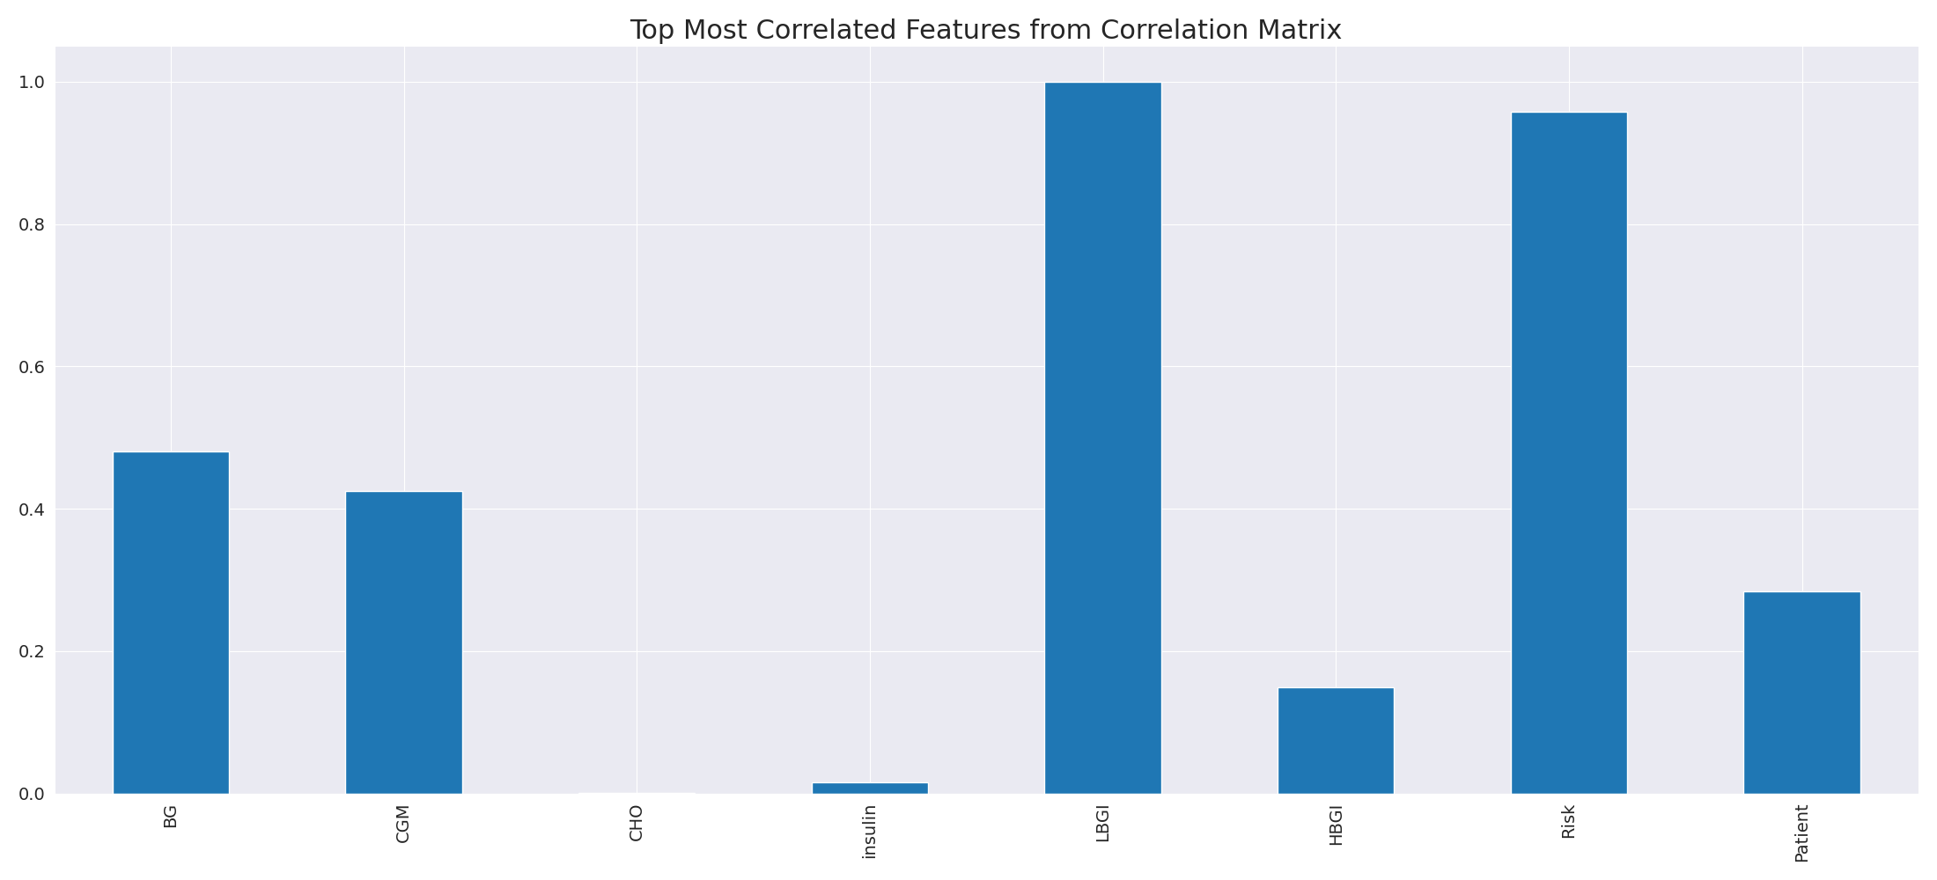

The image displays a line graph with a blue line, representing the most correlated features from a correlation matrix. The line is long and extends from the left to the right side of the graph. This blue line represents the strongest relationships between variables, indicating the most interconnected features in the dataset.  
  
The presence of such strong correlations can provide insights into the underlying patterns and relationships within the data. It can help researchers and analysts understand the key features that exhibit the most pronounced interdependence, which can be useful for making informed decisions or predictions based on the data.  
  
However, it is essential to consider the limitations of correlation analysis, as it may not always provide a complete understanding of the relationships between variables. Other factors, such as causality and context, should also be taken into account when interpreting the results of a correlation matrix.

Missing Numbers Graph Analysis

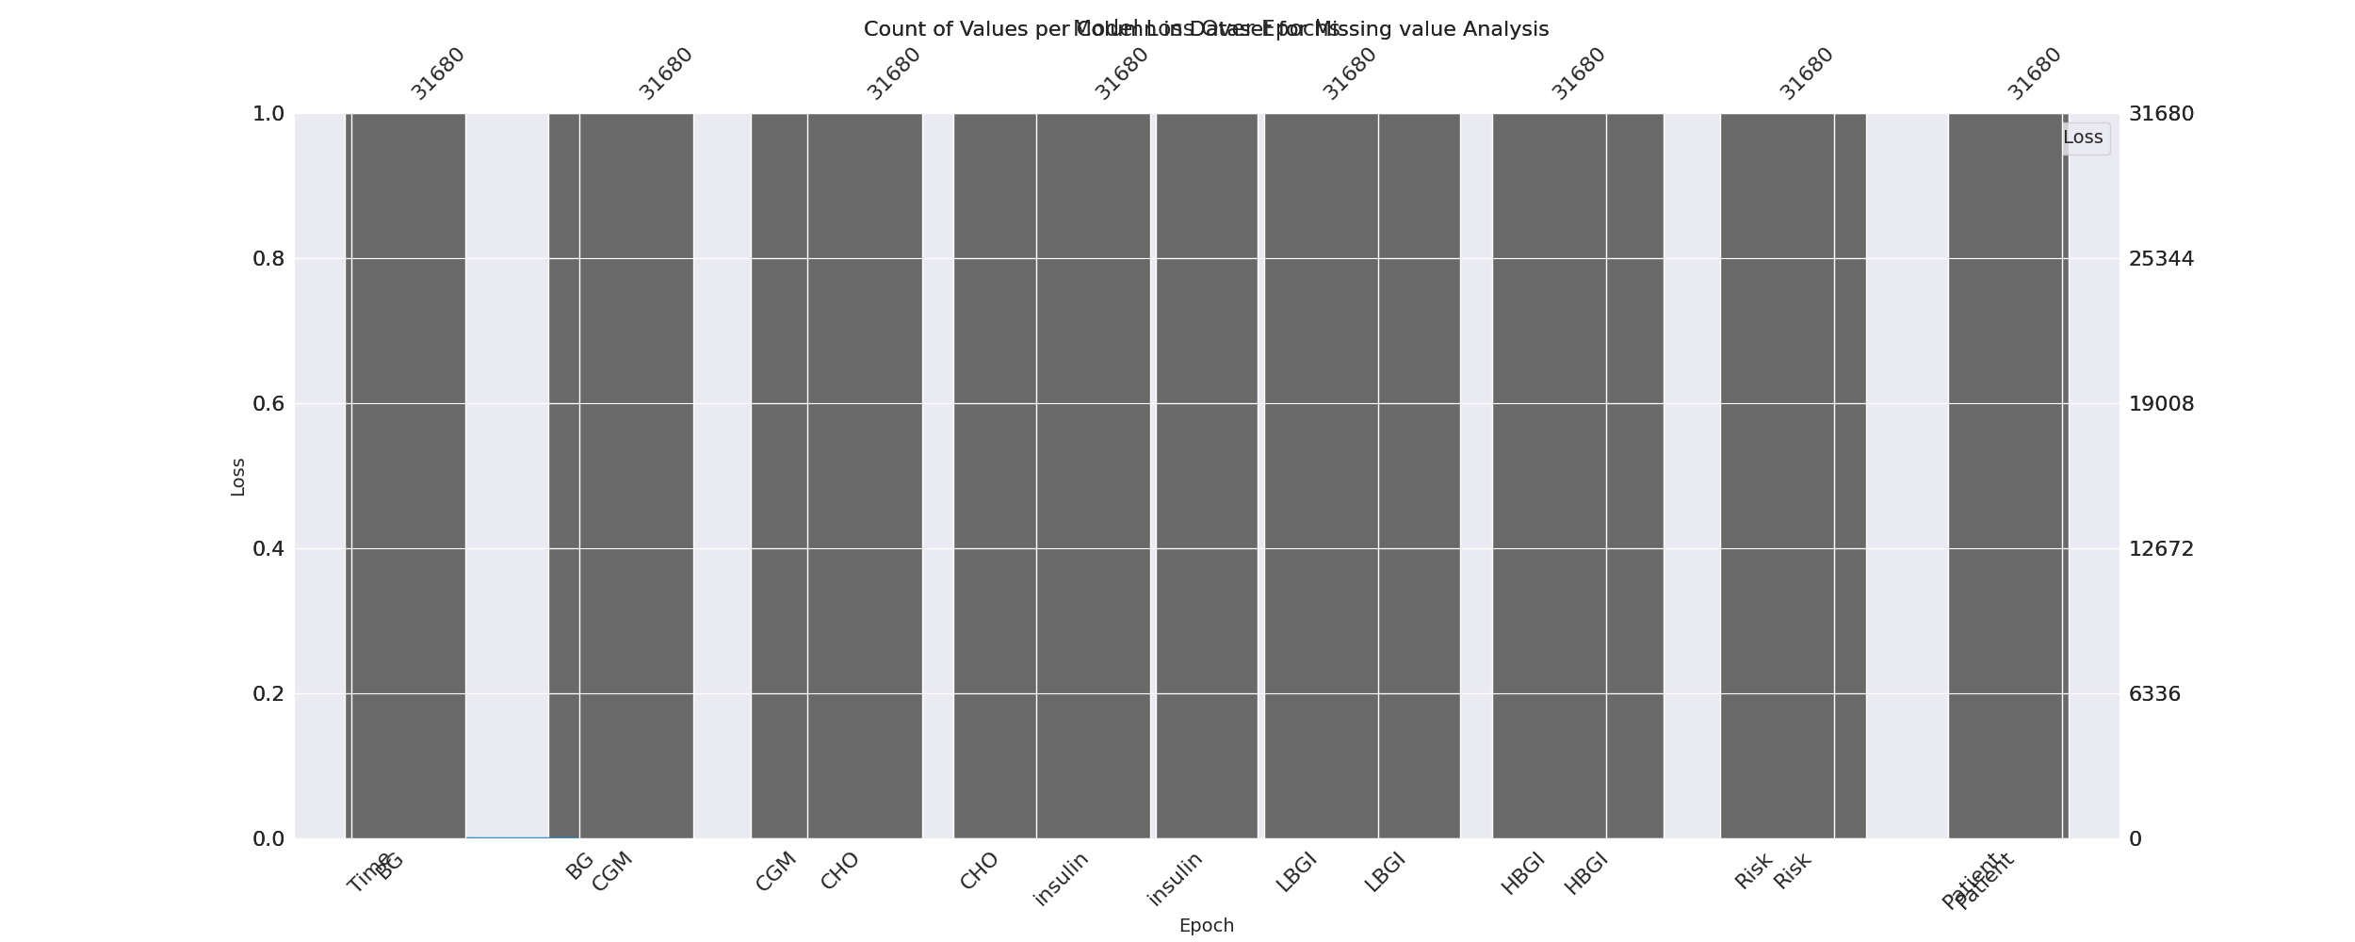

The image displays a graph with a series of numbers, including values and missing values. The numbers are arranged in a line, and the missing values are represented by a blank space. The graph is labeled with the names of the missing values, such as "missing value analysis."  
  
The presence of missing values in the data can impact data analysis or modeling in several ways. It may lead to biased or inaccurate conclusions, as the missing values could be indicative of certain trends or patterns that are not being captured. To address this issue, exploratory data analysis (EDA) techniques can be employed to identify missing values and understand their impact on the data.  
  
EDA techniques involve visualizing the data, looking for patterns, and identifying outliers. By examining the distribution of the data, one can identify the missing values and assess their impact on the overall analysis. For instance, if the missing values are concentrated in a specific region or demographic, it may be necessary to adjust the analysis to account for this bias.  
  
In conclusion, the image highlights the importance of addressing missing values in data analysis and modeling. By employing EDAs, one can better understand the impact of missing values and adjust the analysis accordingly.

Heat_Explainer Graph Analysis

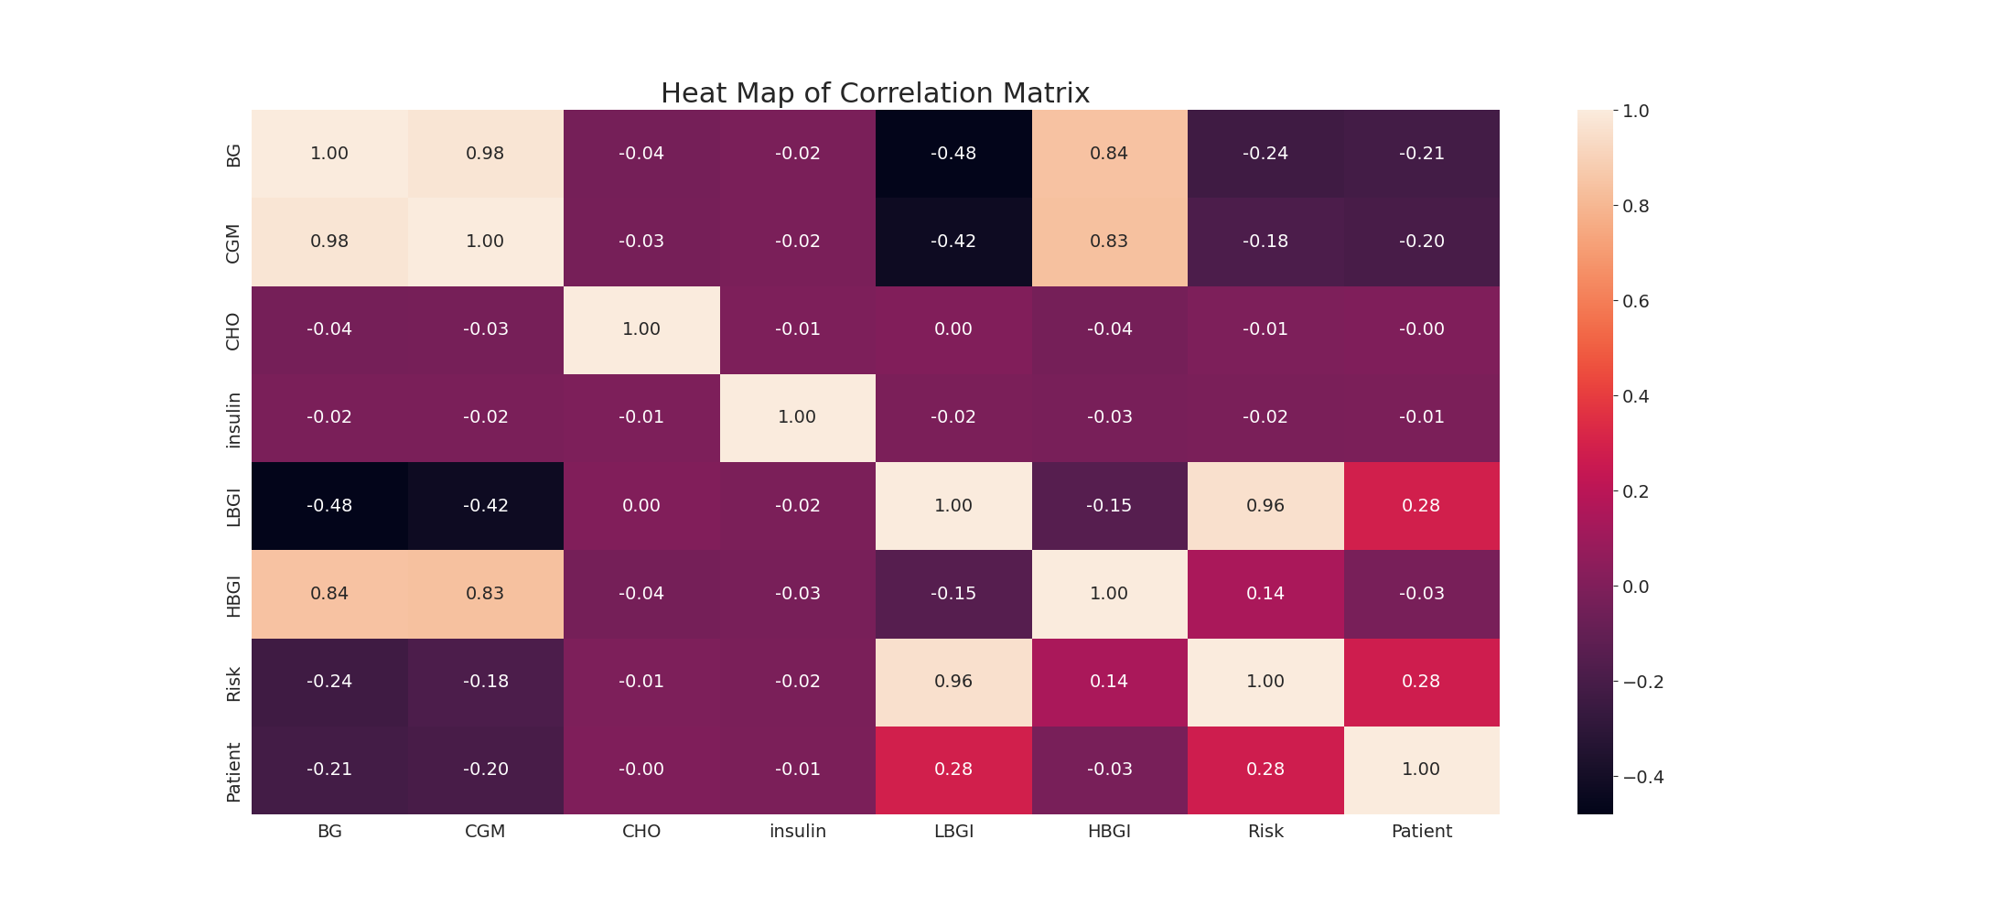

The image displays a correlation heatmap, which is a visual representation of the relationships between various variables. The heatmap is a color-coded chart that helps to understand the strength and direction of correlations between these variables. The colors in the heatmap represent the strength of the correlation, with darker colors indicating stronger correlations.  
  
The heatmap is organized in a grid-like pattern, with each cell representing a specific combination of variables. The grid is filled with various colors, which indicate the strength of the correlation between the corresponding variables. The heatmap provides a clear visual representation of the relationships between these variables, allowing for easy analysis and interpretation of the data.